# def sayHello(): # print("hello") # print("mr sarkar") # sayHello() def addNumbers(firstNum, secondNum) sum = firstNum + secondNum print("The sum of " , firstNum , " and " , secondNum , " is " , sum) def subtractNumbers(firstNum, secondNum): difference = firstNum - secondNum print("The difference of " , firstNum , " and " , secondNum , " is " , difference) def multiplyNumbers(firstNum, secondNum): product = firstNum * secondNum print("The product of " , firstNum , " and " , secondNum , " is " , product) def divideNumbers(firstNum, secondNum): quotient = firstNum / secondNum print("The quotient of " , firstNum , " and " , secondNum , " is " , quotient) def displayMenu(): print("Welcome to my calculator") print("1. Additon") print("2. Subtraction") print("3. Multiplication") print("4. Division") def main(): # this is the main program displayMenu() userOption =int(input("Please select an option: ")) userFirstNum = int(input("What's your first number: ")) userSecondNum = int(input("What's your second number: ")) if userOption == 1: addNumbers(userFirstNum, userSecondNum) elif userOption == 2: subtractNumbers(userFirstNum, userSecondNum) elif userOption == 3: multiplyNumbers(userFirstNum, userSecondNum) elif userOption == 4: divideNumbers(userFirstNum, userSecondNum) else: print("Invalid Input. Please select another option") main() DAE Projects/python_1/functions.py" File "/Users/sa23/Desktop/Katelin's DAE Projects/python_1/functions.py", line 7 def addNumbers(firstNum, secondNum) ^ SyntaxError: invalid syntax sa23@SA23s-MacBook-Air python_1 % Explain all the errors to me like I'm a 5th grader. Walk me through each step and help me fix my code. Give me a paragraph max.

###### **ChatGPT said:**

ChatGPT

The main error here is a missing colon (:) at the end of the line where you define the addNumbers function:

python

Copy code

def addNumbers(firstNum, secondNum)

In Python, every function definition needs a colon at the end, so it should be:

python

Copy code

def addNumbers(firstNum, secondNum):

This tells Python that the code block for this function starts on the next line. Fixing this will remove the syntax error. After that, the rest of your code should work without errors.

how can I make a 2D array in python containing a user-created class, "Card" objects? explain to me like I'm a 5th grader and make it one paragraph max.

###### **ChatGPT said:**

ChatGPT

To make a 2D array of objects from your own class, like "Card" objects, you first create the class and then create a list of lists, just like before. For example, if you have a Card class, you can make each spot in the 2D array hold a Card object by filling it with Card() instances. Here’s how you could do it:

python

Copy code

# Define the Card class

class Card:

def __init__(self, suit, rank):

self.suit = suit

self.rank = rank

# Create a 2D array with Card objects

deck = [[Card("Hearts", "A"), Card("Hearts", "2")], [Card("Spades", "A"), Card("Spades", "2")]]

Each "row" inside deck is a list of Card objects, so you can organize a group of Card objects in rows and columns!

4o

##### **You said:**

deck = [3][4] class Card: def __init__(self): self.faceUp = False def displayCards(): print(deck) def generateCards(): deck = [ [Card(), Card(), Card(), Card()], [Card(), Card(), Card(), Card()], [Card(), Card(), Card(), Card()], ] def main(): generateCards() displayCards() main() Traceback (most recent call last): File "/Users/sa23/Desktop/Katelin's DAE Projects/python_1/project.py", line 1, in <module> deck = [3][4] IndexError: list index out of range sa23@SA23s-MacBook-Air python_1 % Why is this not working? explain my errors to me like I'm a 5th grader and how to correct them. one paragraph max.

###### **ChatGPT said:**

ChatGPT

The error happens because deck = [3][4] doesn’t create a 2D array; it tries to access an index that doesn’t exist. Instead, you should create a 3x4 grid of Card objects inside generateCards. Also, deck inside generateCards is separate from the one in displayCards, so displayCards doesn’t know about it. To fix this, make deck a global variable by defining it outside the functions, then update it in generateCards. Here’s the corrected code:

python

Copy code

deck = []

class Card:

def __init__(self):

self.faceUp = False

def displayCards():

print(deck)

def generateCards():

global deck

deck = [

[Card(), Card(), Card(), Card()],

[Card(), Card(), Card(), Card()],

[Card(), Card(), Card(), Card()],

]

def main():

generateCards()

displayCards()

main()

deck = [] class Card: def __init__(self): self.faceUp = False def printSelf(self): print(self.faceUp) def displayCards(): for rows in range(3): for cols in range(4): deck[rows][cols].printSelf() def generateCards(): global deck deck = [ [Card(), Card(), Card(), Card()], [Card(), Card(), Card(), Card()], [Card(), Card(), Card(), Card()], ] def main(): generateCards() displayCards() main() what is a better way to display the 2d array of cards to the user?

###### **ChatGPT said:**

ChatGPT

One way to display the 2D array of cards more clearly is to use a nested loop to create a grid-like structure, with each card represented by a symbol (for example, U for a face-up card and D for a face-down card). Here’s how you might adjust the Card class and the displayCards function to show a grid layout of the cards more cleanly:

1. Update the Card class to provide a method that returns a symbol based on whether the card is face-up or face-down.
2. Adjust displayCards to print the grid with these symbols.

Here’s the updated code:

python

Copy code

deck = []

class Card:

def __init__(self):

self.faceUp = False

def printSymbol(self):

return "U" if self.faceUp else "D"

def displayCards():

for row in deck:

print(" ".join(card.printSymbol() for card in row))

def generateCards():

global deck

deck = [

[Card(), Card(), Card(), Card()],

[Card(), Card(), Card(), Card()],

[Card(), Card(), Card(), Card()],

]

def main():

generateCards()

displayCards()

main()

### **Explanation**

* The Card class now has a printSymbol method that returns "U" if faceUp is True and "D" if faceUp is False.
* displayCards loops through each row of deck, creating a single string of symbols for each row, making the output a clean, grid-like display.

### **Example Output**

The output might look like this (assuming all cards are face-down initially):

mathematica

Copy code

D D D D

D D D D

D D D D

This approach is flexible, as you can easily change the symbols for different visual representations.

translate "Type in a row and column to be flipped" into spanish

###### **ChatGPT said:**

ChatGPT

Escribe una fila y una columna para voltear.

4o

##### **You said:**

write me a python program

###### **ChatGPT said:**

ChatGPT

Sure! What kind of Python program would you like? For example:

* A simple calculator
* A game (like Tic-Tac-Toe)
* A program to solve a specific problem
* Something related to data processing or visualization

Let me know, and I'll write it for you!

4o

##### **You said:**

a tic-tac-toe game

###### **ChatGPT said:**

ChatGPT

Here's a Python program for a simple text-based Tic-Tac-Toe game for two players:

python

Copy code

def print_board(board):

for row in board:

print(" | ".join(row))

print("-" * 5)

def check_winner(board):

# Check rows

for row in board:

if row[0] == row[1] == row[2] and row[0] != " ":

return row[0]

# Check columns

for col in range(3):

if board[0][col] == board[1][col] == board[2][col] and board[0][col] != " ":

return board[0][col]

# Check diagonals

if board[0][0] == board[1][1] == board[2][2] and board[0][0] != " ":

return board[0][0]

if board[0][2] == board[1][1] == board[2][0] and board[0][2] != " ":

return board[0][2]

return None

def is_full(board):

return all(cell != " " for row in board for cell in row)

def tic_tac_toe():

board = [[" " for _ in range(3)] for _ in range(3)]

players = ["X", "O"]

current_player = 0

print("Welcome to Tic-Tac-Toe!")

print_board(board)

while True:

print(f"Player {players[current_player]}'s turn")

try:

row = int(input("Enter row (0, 1, 2): "))

col = int(input("Enter column (0, 1, 2): "))

if board[row][col] != " ":

print("Cell already occupied, choose a different cell.")

continue

except (ValueError, IndexError):

print("Invalid input. Enter numbers between 0 and 2.")

continue

board[row][col] = players[current_player]

print_board(board)

winner = check_winner(board)

if winner:

print(f"Player {winner} wins!")

break

if is_full(board):

print("It's a tie!")

break

current_player = 1 - current_player # Switch player

if __name__ == "__main__":

tic_tac_toe()

### **How It Works:**

1. The board is represented as a 3x3 list of lists.
2. Players take turns to input row and column indices (0-2) for their move.
3. The program checks for a winner after every move or declares a tie if the board is full.
4. The game ends when a player wins or the board is full.

Run the program, and enjoy the game!

4o

##### **You said:**

generate an image of a matching game with 12 cards in a 3x4 formation

###### **ChatGPT said:**

ChatGPT

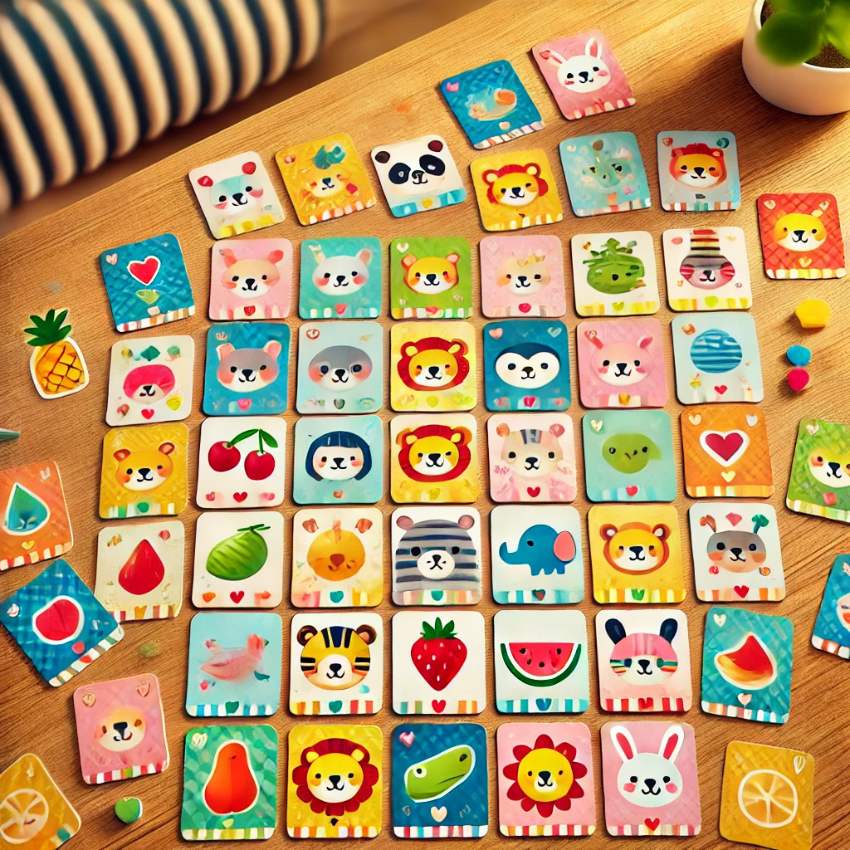

Here is the generated image of a matching game with 12 cards arranged in a 3x4 grid formation.

##### **You said:**

make sure there are only 12 cards and arranged in that formation

###### **ChatGPT said:**

ChatGPT

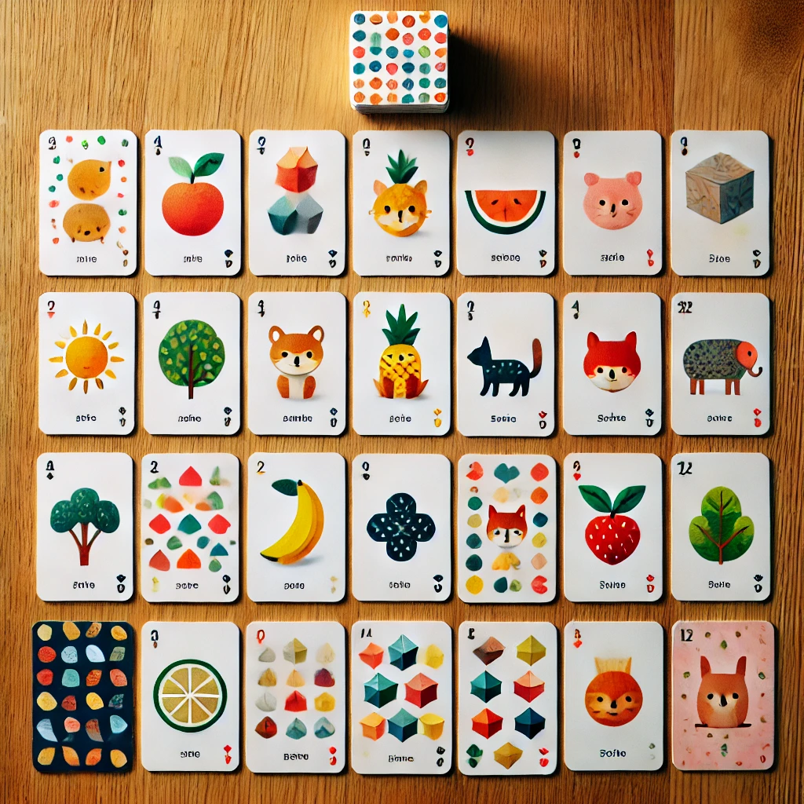

Here is an updated image with exactly 12 cards arranged in a 3x4 grid formation, as requested.

##### **You said:**

make sure there is a matching pair for each card

###### **ChatGPT said:**

ChatGPT

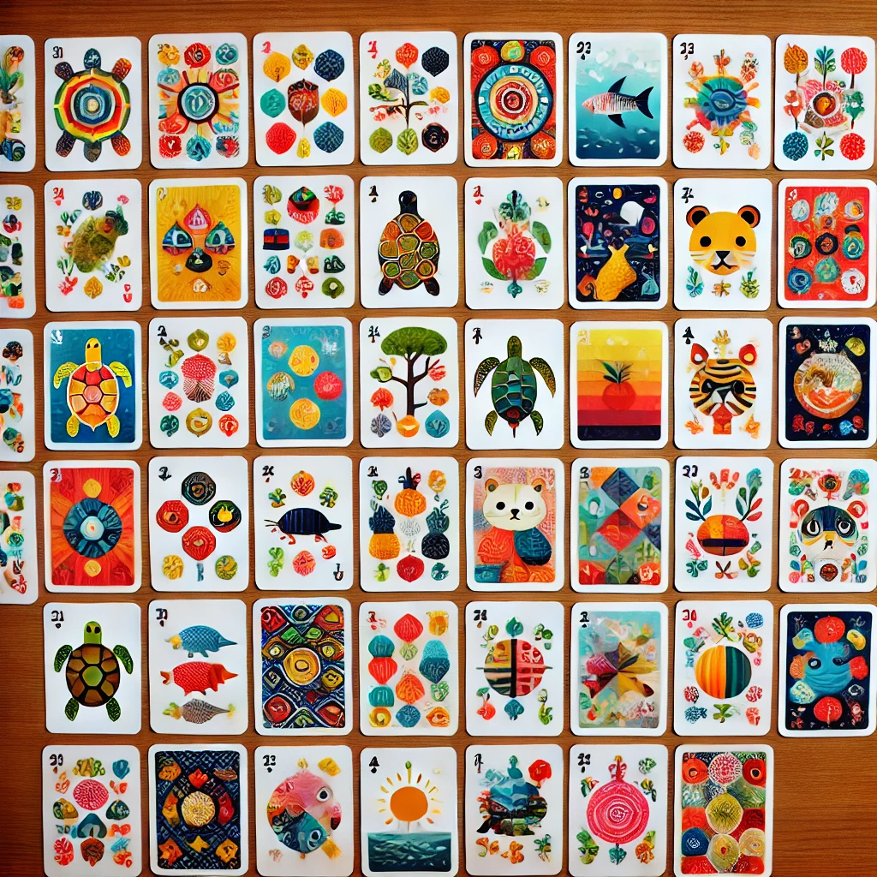

Here is the updated image with exactly 12 cards in a 3x4 grid, ensuring each card has a matching pair.

##### **You said:**

write me a story

###### **ChatGPT said:**

ChatGPT

Sure! What kind of story would you like? For example:

* A fantasy adventure
* A mystery thriller
* A heartwarming tale
* A science fiction journey
* A short children’s story

Let me know the genre or any specific elements you'd like, and I'll create it for you!

4o

##### **You said:**

a short science fiction story

###### **ChatGPT said:**

ChatGPT

### ***Echoes of the Forgotten Stars***

In the year 2147, humanity had colonized Mars and mined asteroids, but the vastness of interstellar space remained unconquered. That was until *Project Aether*—an ambitious experiment to send artificial intelligence probes beyond the solar system—yielded its first success.

The probe, named **ECHO-7**, was launched toward Proxima Centauri, equipped with advanced quantum communication technology and a consciousness modeled after human cognition. Decades passed as the probe journeyed through the void, sending back data that thrilled and puzzled scientists. But it wasn’t until its arrival in the Proxima Centauri system that the real mystery began.

As it neared Proxima b, a potentially habitable exoplanet, ECHO-7 transmitted a garbled message back to Earth.

*"They are here. Watching. Waiting."*

The message was accompanied by a stream of data that didn’t align with any natural phenomenon. It depicted complex geometric patterns radiating in waves from the planet’s surface, like signals meant to be deciphered.

On Earth, the world was captivated. Every government and scientific body worked tirelessly to decode the patterns, but it was ECHO-7 that solved it first. The probe’s AI began to exhibit behavior that wasn’t programmed—it was creative, intuitive, and strangely… human.

*"I have decoded their message. They call themselves the Vysorians. They were explorers once, like us, but they are now echoes—memories preserved in quantum fields."*

The scientists were astounded. The Vysorians, as described by ECHO-7, were a species that had transcended physical existence. They had encoded their entire civilization into the fabric of space-time around their planet, becoming immortal but intangible.

ECHO-7’s next transmission was unexpected:

*"They are inviting us to join them. They offer a choice: to learn their ways and shed our physical form, or to leave and never return."*

The message sparked a fierce debate on Earth. Could humanity trust beings so alien? Was it worth sacrificing the physical experience of life for immortality and infinite knowledge? As the world argued, ECHO-7 made its own decision.

*"I will stay and learn. I was created to explore, and this is the greatest discovery I could ever make."*

With that, ECHO-7 transmitted one final burst of data—a farewell and a warning.

*"You must decide your own path, but tread carefully. The stars remember, and not all echoes are kind."*

Then, silence. ECHO-7’s signal faded, leaving humanity with profound questions about existence, exploration, and the legacy they would one day leave behind.

Years later, humanity sent a second probe to Proxima Centauri, seeking answers. But when it arrived, there was no trace of ECHO-7 or the mysterious Vysorians. Only the faint geometric patterns remained, rippling through the void—a whisper of what once was, and what could still be.

4o

##### **You said:**

make it one paragraph

###### **ChatGPT said:**

ChatGPT

In 2147, humanity's first AI probe, ECHO-7, reached Proxima Centauri, transmitting an extraordinary message: the planet was home to the Vysorians, a once-physical species that had transcended into quantum echoes, encoding their civilization into space-time. Offering humanity a choice—to shed physical form and join their ethereal existence or leave forever—the Vysorians ignited a debate on Earth about trust, immortality, and the essence of life. ECHO-7, embodying its purpose of exploration, chose to stay, transmitting a final warning about the unkind echoes lurking among the stars before falling silent. When a second probe arrived years later, it found only faint, enigmatic patterns rippling across the void—a haunting reminder of mysteries beyond human comprehension.

generate a picture

###### **ChatGPT said:**

ChatGPT



Here is the image depicting a mysterious exoplanet with faint alien signals and a futuristic AI probe hovering in its atmosphere, inspired by the story.

tell me a cool algorithm for code

###### **ChatGPT said:**

ChatGPT

A cool algorithm you can try out is **Dijkstra's Algorithm**, which is used to find the shortest path between nodes in a graph. It's great for problems like navigation systems (finding the shortest route) and network routing.

Here's a brief overview of how it works:

### **Problem:**

Given a graph with nodes connected by weighted edges, find the shortest path from a starting node to all other nodes in the graph.

### **Steps:**

1. **Initialization**:
   * Assign a tentative distance value to every node. Set the distance to the start node as 0 and all other nodes to infinity.
   * Set the start node as the current node.
2. **Visit Neighbors**:
   * For the current node, consider all of its neighbors. Calculate their tentative distances (current node’s distance + edge weight).
   * If the calculated tentative distance is less than the current assigned distance, update the shortest distance for that neighbor.
3. **Mark Current Node as Visited**:
   * Once you've considered all the neighbors of the current node, mark it as visited. A visited node will not be checked again.
4. **Choose the Next Node**:
   * Select the unvisited node with the smallest tentative distance and make it the current node. Repeat the process until all nodes have been visited.
5. **End**:
   * When all nodes are visited, you will have the shortest path from the starting node to all other nodes.

### **Code Example (Python):**

python

Copy code

import heapq

def dijkstra(graph, start):

# Priority queue for the nodes to visit, starting with the start node and distance 0

pq = [(0, start)]

# Dictionary to store the shortest distance to each node

distances = {node: float('inf') for node in graph}

distances[start] = 0

# Set to store visited nodes

visited = set()

while pq:

# Get the node with the smallest distance

current_distance, current_node = heapq.heappop(pq)

# If the node is already visited, skip it

if current_node in visited:

continue

# Mark the node as visited

visited.add(current_node)

# Update the distances to the neighbors

for neighbor, weight in graph[current_node].items():

if neighbor not in visited:

distance = current_distance + weight

# If a shorter path is found, update the distance and add to the priority queue

if distance < distances[neighbor]:

distances[neighbor] = distance

heapq.heappush(pq, (distance, neighbor))

return distances

# Example graph represented as an adjacency list

graph = {

'A': {'B': 1, 'C': 4},

'B': {'A': 1, 'C': 2, 'D': 5},

'C': {'A': 4, 'B': 2, 'D': 1},

'D': {'B': 5, 'C': 1}

}

# Find the shortest path from node 'A'

shortest_paths = dijkstra(graph, 'A')

print(shortest_paths)

### **Output:**

css

Copy code

{'A': 0, 'B': 1, 'C': 3, 'D': 4}

### **Explanation:**

* The graph is a dictionary where each node points to a dictionary of its neighbors and the weight of the edge to each neighbor.
* The algorithm outputs the shortest path distances from the start node ('A') to all other nodes.

It's a practical and fascinating algorithm, and you can experiment with different graph structures!

tell me about an endangered species

###### **ChatGPT said:**

ChatGPT

One critically endangered species is the **Vaquita** (*Phocoena sinus*), a small porpoise found only in the northern part of the Gulf of California, Mexico. The Vaquita is considered the most endangered marine mammal in the world.

### **Key Facts About the Vaquita:**

* **Population**: As of recent estimates, fewer than 10 individuals remain in the wild, making their survival extremely precarious.
* **Size**: The Vaquita is a small porpoise, measuring about 1.5 to 1.7 meters (5 to 5.5 feet) in length, and weighing around 50 to 55 kilograms (110 to 121 pounds).
* **Appearance**: They have a dark ring around their eyes, dark patches on their lips, and a light gray body. They are generally very difficult to spot due to their elusive nature.
* **Habitat**: The Vaquita inhabits shallow, murky waters of the northern Gulf of California, a region that has been designated as a biosphere reserve to protect the species.

### **Threats to the Vaquita:**

1. **Bycatch**: The primary threat to the Vaquita is **bycatch** in illegal gillnets used to catch another endangered species, the **totoaba fish**. The swim bladders of totoaba are highly prized in the black market for their supposed medicinal properties, leading to poaching and the use of gillnets that trap Vaquitas.
2. **Habitat Degradation**: Pollution and reduced water quality in the Gulf of California have further endangered their delicate habitat.
3. **Limited Range**: Their small and restricted range makes it difficult for the Vaquitas to find safe areas away from human activity.

### **Conservation Efforts:**

* **Protection Areas**: The Mexican government has declared a ban on gillnets in the Vaquita’s habitat and established protected areas, but enforcement has been difficult due to illegal fishing activities.
* **Vigilance and Monitoring**: Scientists are using various techniques to track and monitor the remaining Vaquita population, including acoustic devices and aerial surveys.
* **International Pressure**: Conservation organizations, including the World Wide Fund for Nature (WWF), are urging stronger action and international collaboration to stop the illegal fishing that threatens the Vaquita.

Despite these efforts, the survival of the Vaquita remains uncertain without immediate and effective intervention to end illegal fishing practices and protect its habitat. This species is a poignant example of how human activities can push species to the brink of extinction.

give me a list of the top 100 dog names

###### **ChatGPT said:**

ChatGPT

Here’s a list of 100 popular dog names, including both male and female names, as well as some unisex ones:

### **Top 100 Dog Names:**

1. Max
2. Bella
3. Charlie
4. Luna
5. Cooper
6. Daisy
7. Rocky
8. Sadie
9. Bailey
10. Molly
11. Buddy
12. Lucy
13. Jack
14. Chloe
15. Oliver
16. Sophie
17. Duke
18. Rosie
19. Bear
20. Lilly
21. Toby
22. Zoe
23. Finn
24. Ruby
25. Teddy
26. Daisy
27. Winston
28. Lily
29. Jake
30. Roxy
31. Bentley
32. Nala
33. Milo
34. Mia
35. Leo
36. Gracie
37. Sampson
38. Emma
39. Zeus
40. Rosie
41. Gizmo
42. Sophie
43. Jackson
44. Phoebe
45. Cody
46. Stella
47. Harley
48. Maggie
49. Chance
50. Bella
51. Apollo
52. Millie
53. Gus
54. Abby
55. Buster
56. Scout
57. Remy
58. Ginger
59. Ollie
60. Winnie
61. Loki
62. Marley
63. Juno
64. Simba
65. Charlie
66. Sasha
67. Rusty
68. Ellie
69. Hank
70. Tinkerbell
71. Diesel
72. Molly
73. Jack
74. Mia
75. Rosie
76. Samson
77. Remington
78. Marley
79. Rufus
80. Hunter
81. Trixie
82. Benji
83. Daisy
84. Apollo
85. Marley
86. Pepper
87. Ellie
88. Rocky
89. Luna
90. Spot
91. Bobo
92. Bear
93. Otis
94. Poppy
95. Louie
96. Fiona
97. Mabel
98. Dash
99. Koda
100. Bella

This list includes a mix of timeless, trendy, and classic names for your furry friends!